Req 1: Create a JavaScript Objects with the following properties:

Id

customerName

phoneNumber

address

loanAmount

interest

loanTermYears

loanType

description

calculatedLoanAmount (\*\* Assign the following business logic to calculate the loan amount. By creating a JavaScript function)

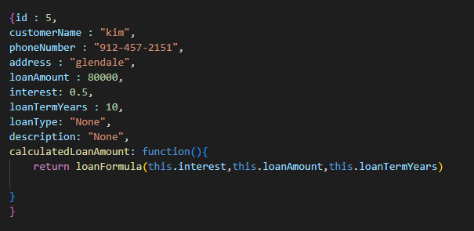

Req 2: Create an array of loans and add five instances of the above JavaScript objects based on the above specifications

Req 3: List all the array elements with the grand total loan amount using console.log statements.

